Summary of the Case Study
Attention-Deficit Hyperactivity Disorder (ADHD).

Case study hyperactivity disorder and attention deficit (ADHD)
Planning and preparation for this study lasted two years.
Study was prepared on (29) children, and the division of children participating in the study into two groups.
Adopted the division of behavioral and psychological disturbances such as the difficulty associated with education and speech problems and disorders like autism.
The first group and the 18 children:
Children in this group infected hyperactivity disorder and attention deficit only.
The second group and the 11 children:
Children in this group infected hyperactivity disorder and attention deficit disorders and other escort.
Details of the study:
- Has been shut down any medication chemical was eating children.
- Dealing with children in both groups medicine (under study), and for two consecutive months, with a focus on behavioral therapy and reducing bad habits such as eating sweets and sugars or addiction to watching TV.
- During the study, the distribution of diet, but with the caveat on the family not to push the child, diet does not contain a specific food by itself or deprivation of other food, just everything in it that the diet focuses on encouraging the child to deal with certain foods.
- The study focused on three main symptoms experienced by children:
1 - permanent movement without any aim. (This is meant by each activity performed by the child without a goal such as running and applause).
2 - Lack of attention and the dispersion of focus.
3 - in response to orders of the child of his parents and teachers.
Results of the study:
Two months after the results of the two groups as follows:
Group I:
1 - permanent movement without any aim.
Less activity and movement of children by a total amount of 94%.
2 - Lack of attention and the dispersion of focus.
To curb the inevitable result of excessive activity increased children's attention and concentration by 89%.
3 - in response to orders of the child of his parents and teachers.
Updated tremendous response with children and their parents and teachers, one of the positives that emerged from the study and the success rate of 95%.
Total marked improvement in symptoms, which focused in the study 92.6%.
Group II:
1 - permanent movement without any aim.
Less activity and movement of children by a total amount of 79%.
2 - Lack of attention and the dispersion of focus.
Increased children's attention and focus is considerable and approach for 76%.
3 - in response to orders of the child of his parents and teachers.
Response occurred with the children and their parents and teachers, and this response is not particularly easy and the ratio approached 65%.
Total marked improvement in symptoms, which focused in the study 73.3%.

The overall result of the study:
Overall, the points above was out by calls for optimism is a general improvement in children by a total of (83%).
Observations on the results of the study:
For the rest of the symptoms and features that experienced by some of the children participating in the study such as aggressive and symptoms of social phobia and other registration have been some positive results.
Exceptions:
Excluded from the study, three cases of two children (5 - 8) years, and a girl (5) years.
Many reasons for the exclusion, including lack of commitment by parents before the table of the study.

Components of natural remedy used
Consists of natural remedy used in the study is:
■ 4 kilo Yemeni Sidr Honey is original, two kilo mixed bee products; royal jelly and pollen.
■ 2 medical herbs Shabtin secure nations are the two medical Valerian and anemone.
■ high-value nutritional supplements are the Khawlani almond, Yemeni raisins and seeds purslane.

التواصل معنا

مركز العلاج الأكاديمي التطبيقي للطب البديل التكميلي
اليمن - صنعاء - شارع أبو ظبي الصافية سابقاً - جوار حراج الصافية - بجانب مدارس النجاح الأهلية.

الموقع الالكتروني: www.pacccam.com
تلفون أرضي: 009671507204 فاكس: 009671267684
موقع العلاج: www.al3laj.com
القسم الخاص بفرط الحركة ونقص الانتباه: www.adhd.al3laj.com
البريد الالكتروني: adhd@al3laj.com

د. سليم طلال الأغبري.
جوال: 00967734948255
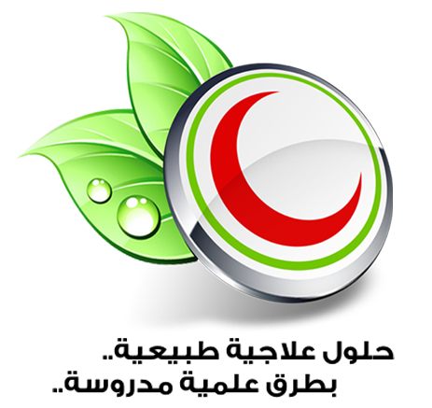

Practical Academic Cure Center For Complementary Alternative Medicine. (PACCCAM)©

